

Mid-Year Outlook 2026: Key Lessons for the Seventh Year of the Cycle

July 28, 2026

Anthony Lishka, ChFC®, ChSNC®, CPFA®, CF2®, FRC | President

As we begin the second half of the year, I wanted to share a mid-year market update with our current perspectives. This includes the key themes shaping markets and what they mean for your portfolio.
Markets Were Strong in the First Half of the Year
The first half of 2026 was a reminder of why staying invested and maintaining a long-term perspective matters. Markets climbed to new all-time highs, corporate earnings grew at a double-digit pace, and a wide range of asset classes delivered strong returns. This all occurred even as the war in Iran, rising energy prices, and uncertainty around the Federal Reserve created short-term turbulence along the way.
Perhaps the most important context is that the current business cycle is now in its seventh year and is going strong. There have been several moments in recent years when a recession seemed possible, including when inflation peaked in 2022 and when tariffs disrupted trade last year. However, the economy has been resilient throughout these periods and continues to grow.
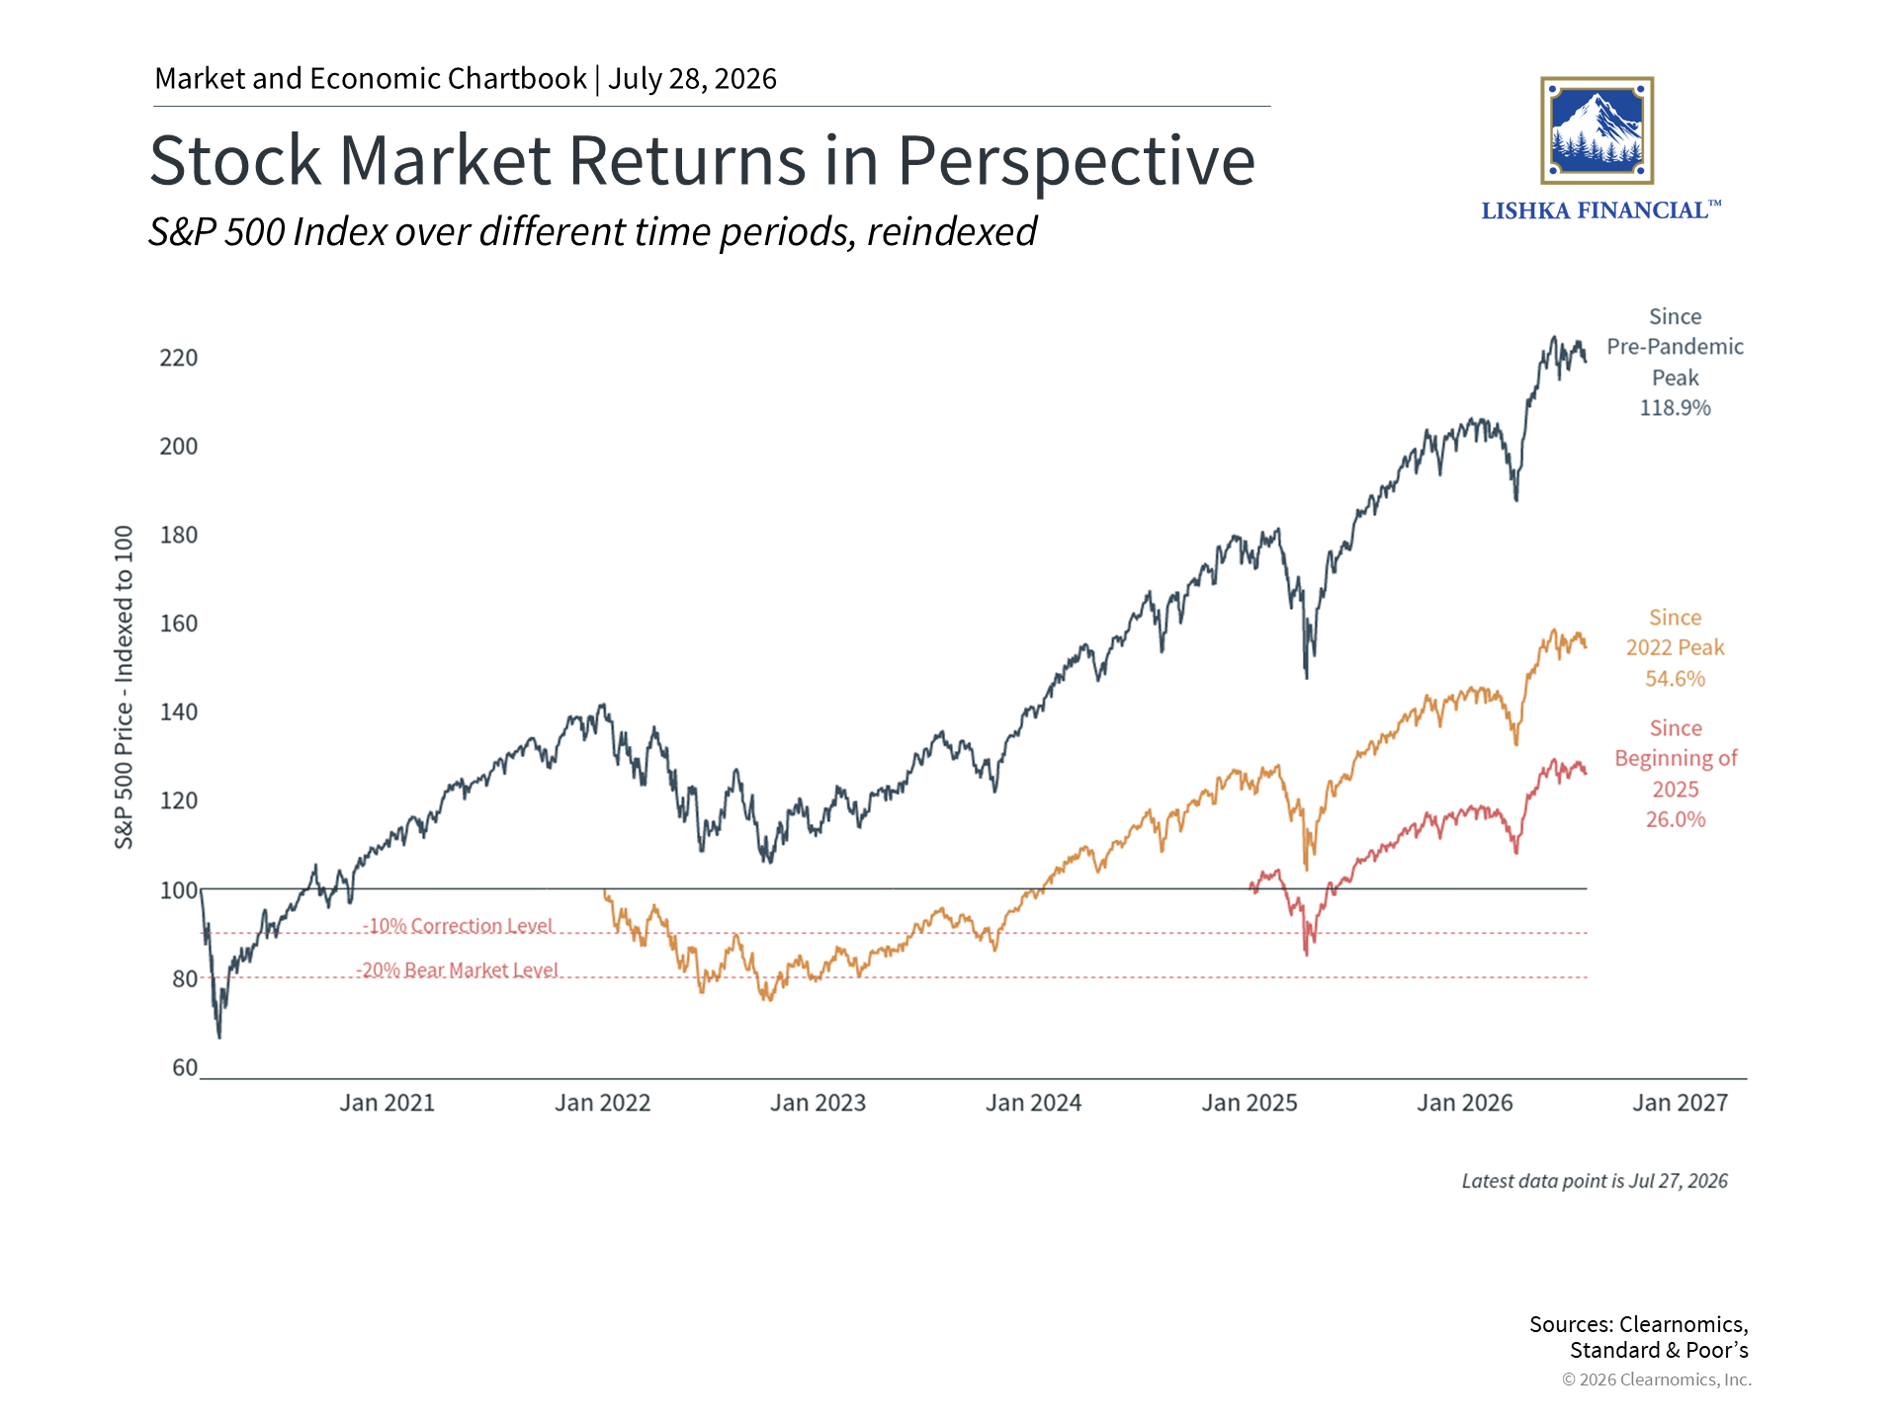
Today, the economic picture remains broadly positive. The job market has strengthened this year, with payroll growth now averaging 111,000 jobs per month, above the long-term average. Consumer spending has also held up, business investment has accelerated due to AI trends, and the dollar has stabilized.
One potential challenge is that inflation remains elevated, largely because of higher energy prices. While the peace deal framework and ceasefire with Iran have been tentative, oil prices have still declined back toward their pre-conflict levels. This suggests that inflation may be near its high point for this cycle, although there are no guarantees on how this develops.
Steady economic growth has supported the stock market, with the S&P 500 reaching 24 new all-time highs so far this year. The S&P 500 returned 9.6% in the first half, while the Nasdaq gained 12.8% and the Dow Jones Industrial Average rose 8.9%. The second quarter was particularly strong, with the S&P 500 returning 14.9%. This was due to the timing of the market rebound, which began at the end of March.
Perhaps just as important is the breadth of performance across global asset classes. Emerging market stocks gained 22.7%, small-cap equities rose nearly as much, and commodities climbed 12.3%, driven largely by a strong first quarter. This kind of broad participation is one of the most encouraging developments for balanced portfolios and continues a positive trend that began last year.
What’s driving this? One major reason is that corporate earnings have supported returns, growing more than 20% over the past twelve months for S&P 500 companies. It is worth noting that U.S. stock valuations are elevated, with the S&P 500 trading at roughly 20 times forward earnings, above the long-term average of 16 times. High valuations do not predict what markets will do in the near term, but they are an important consideration.
For bond holdings, the current yield environment is among the most attractive in recent decades. The Bloomberg U.S. Aggregate Bond Index yields approximately 4.7%, well above its average of 3.0% since 2009. Investment-grade corporate bonds yield 5.1%. Bonds act as a source of income and a stabilizing force in a balanced portfolio.
Looking Ahead to the Second Half
There will no doubt be more periods of market volatility ahead. The war in Iran is ongoing, investors will continue to scrutinize the Fed, and the November midterm elections will attract attention in the media.
On that note, while it can be difficult to do, it’s important to keep our political views and financial goals separate. Markets have historically been positive under every combination of political party control. While headlines out of Washington D.C. may create short-term swings, the true drivers of markets are corporate earnings, economic fundamentals, and the business cycle.
Artificial intelligence continues to be a major theme across markets as well. Large technology companies are investing heavily in AI infrastructure, and high-profile IPOs including OpenAI and Anthropic are anticipated later this year.
Overall, this reflects market optimism. The key lesson from prior technology cycles is to take a longer-term view. During periods of rapid innovation, it can be difficult to identify the long-term winners in advance. The largest technology stocks today have taken decades to grow into the companies they are today.
The bottom line? The first half of 2026 has rewarded investors who remained diversified and focused on the long term, even as geopolitical and economic headlines created short-term uncertainty. As we navigate the second half of the year, it’s important to remember that your portfolio is designed for exactly this kind of environment.

As always, please do not hesitate to reach out if you have any questions or would simply like to discuss what any of these developments mean for your specific situation and goals.
Best regards,
Your Lishka Financial® team

Securities and advisory services offered through LPL Financial, a Registered Investment Advisor, member FINRA/SIPC.
The information contained in this email message is being transmitted to and is intended for the use of only the individual(s) to whom it is addressed. If the reader of this message is not the intended recipient, you are hereby advised that any dissemination, distribution or copying of this message is strictly prohibited. If you have received this message in error, please immediately delete.
Copyright (c) 2026 Clearnomics, Inc. All rights reserved. The information contained herein has been obtained from sources believed to be reliable, but is not necessarily complete and its accuracy cannot be guaranteed. No representation or warranty, express or implied, is made as to the fairness, accuracy, completeness, or correctness of the information and opinions contained herein. The views and the other information provided are subject to change without notice. All reports posted on or via www.clearnomics.com or any affiliated websites, applications, or services are issued without regard to the specific investment objectives, financial situation, or particular needs of any specific recipient and are not to be construed as a solicitation or an offer to buy or sell any securities or related financial instruments. Past performance is not necessarily a guide to future results. Company fundamentals and earnings may be mentioned occasionally, but should not be construed as a recommendation to buy, sell, or hold the company's stock. Predictions, forecasts, and estimates for any and all markets should not be construed as recommendations to buy, sell, or hold any security--including mutual funds, futures contracts, and exchange traded funds, or any similar instruments. The text, images, and other materials contained or displayed in this report are proprietary to Clearnomics, Inc. and constitute valuable intellectual property. All unauthorized reproduction or other use of material from Clearnomics, Inc. shall be deemed willful infringement(s) of this copyright and other proprietary and intellectual property rights, including but not limited to, rights of privacy. Clearnomics, Inc. expressly reserves all rights in connection with its intellectual property, including without limitation the right to block the transfer of its products and services and/or to track usage thereof, through electronic tracking technology, and all other lawful means, now known or hereafter devised. Clearnomics, Inc. reserves the right, without further notice, to pursue to the fullest extent allowed by the law any and all criminal and civil remedies for the violation of its rights.

